CMPE 124 Lab 7: Traffic Lights

Hoang Le, 012679771, CMPE 124 Spring 2019, Lab Section #03

***Abstract* —The purpose of this lab is using material learned throughout semester to design a set of traffic light within three phases. Students will design a traffic light within three phases for pedestrian and car.**

# INTRODUCTION

The traffic lights project is a huge project which has three phases which is using 74LS74 (Dual D-type flipflop), 74LS163 (synchronous 4 bit counter), and the interlock between 74LS74 and 74LS163. Basically, when a pedestrian manually pressed a switch, a state machine sequence is started to control the lights. When a car approaches the crossing line, a switch on the road triggers a state machine that sequences the lights to change the control of the car traffic.

# Design methodology

The circuit is starting from the given circuit. Using the given circuit design the state machine with different states. Whenever, the pedestrian presses the request button, and the clock start running. Then, the light change from red to green. However, when the car switch turns on, the pedestrian switch will turn off.

Each phase is developed from the previous state, and the complete state is building a real traffic light as the time off for red takes 11 seconds and yellow takes 4 seconds

## Parts List

* 2 SN74LS74N
* 1 SN74LS163AN
* 2 SN74LS08N
* 9 1KΩ Resistors
* 2 SN74LS04N
* 1 SN74LS10N
* 4 SPDT switch
* 2 Red LED
* 2 Yellow LED
* 2 Green LED

## True table

Table 1: Excitation table for Phase 1 and 2 for car traffic light.

|  |  |  |  |  |  |  |  |  |  |
| --- | --- | --- | --- | --- | --- | --- | --- | --- | --- |
|  | Q1 | Q0 | I | Q1+ | Q0+ | R | G | Y | clrCS |
| S0 | 0 | 0 | 0 | 0 | 0 | 1 | 0 | 0 | 0 |
| S0 | 0 | 0 | 1 | 0 | 1 | 1 | 0 | 0 | 0 |
| S1 | 0 | 1 | 0 | 1 | 1 | 0 | 1 | 0 | 0 |
| S1 | 0 | 1 | 1 | 1 | 1 | 0 | 1 | 0 | 0 |
| S2 | 1 | 1 | 0 | 1 | 0 | 0 | 1 | 0 | 0 |
| S2 | 1 | 1 | 1 | 1 | 0 | 0 | 1 | 0 | 0 |
| S3 | 1 | 0 | 0 | 0 | 0 | 0 | 0 | 1 | 1 |
| S3 | 1 | 0 | 1 | 0 | 0 | 0 | 0 | 1 | 1 |

Table 1: Excitation table for Phase 1 and 2 for pedestrian traffic light.

|  |  |  |  |  |  |  |
| --- | --- | --- | --- | --- | --- | --- |
|  | Q | I | Q+ | R | G | clrPS |
| S0 | 0 | 0 | 1 | 1 | 0 | 0 |
| S0 | 0 | 1 | 1 | 1 | 0 | 0 |
| S1 | 1 | 0 | 0 | 0 | 1 | 1 |
| S1 | 1 | 1 | 0 | 0 | 1 | 1 |

Table 2: Truth table for phase 3:

|  |  |  |  |
| --- | --- | --- | --- |
| Car Red light | Car Red light/ | ReqPsrv | cBSY |
| 0 | 1 | 0 | 0 |
| 0 | 1 | 1 | 1 |
| 1 | 0 | 0 | 0 |
| 1 | 0 | 1 | 0 |

Table 3: Truth table for phase 3:

|  |  |  |  |
| --- | --- | --- | --- |
| Pedestrian Green Light | ReqCsrv | cBSY/ | pBSY |
| 0 | 0 | 0 | 0 |
| 0 | 0 | 1 | 0 |
| 0 | 1 | 0 | 0 |
| 0 | 1 | 1 | 0 |
| 1 | 0 | 0 | 0 |
| 1 | 0 | 1 | 0 |
| 1 | 1 | 0 | 0 |
| 1 | 1 | 1 | 1 |

## K-map

K-map for phase 1:

Car:

## Original and Derived Equations

Equations for phases 1

Car: Red = Q1'*Q0'

Yellow = Q1*Q0'

Green = Q0

Pedestrian:

Green = Q0

Red = Q0’

## Schematics

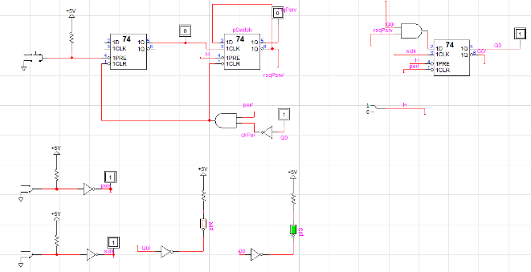

**Figure 1**: Phase 1 for car

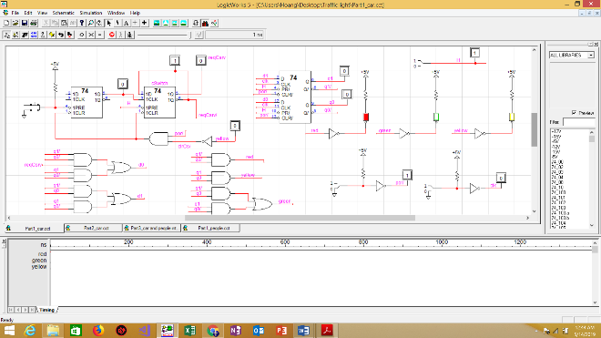

**Figure 2**: Phase 1 for people

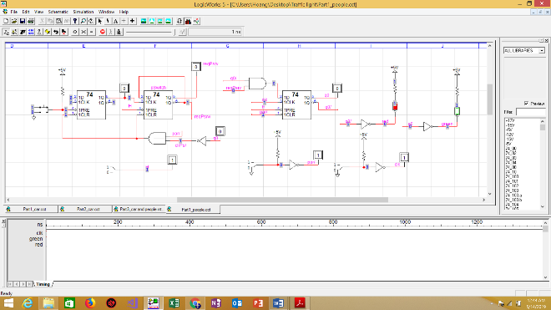

**Figure 3**: Phase 2 for car

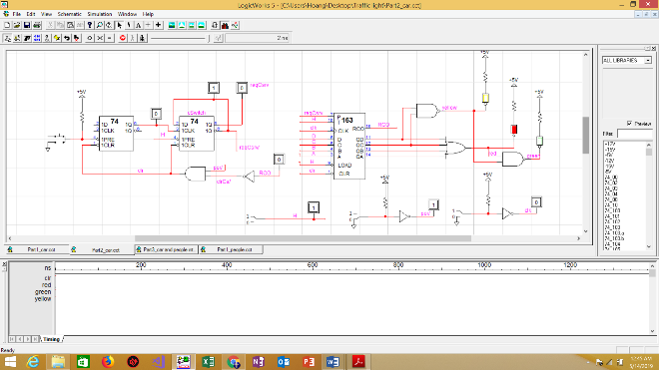

**Figure 4**: Phase 2 for people

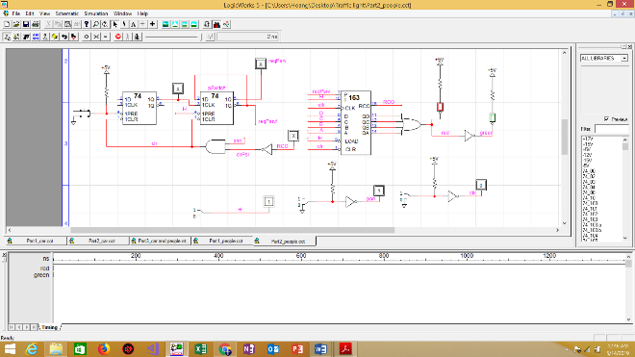

**Figure 5**: Phase 3 for car and people interlock

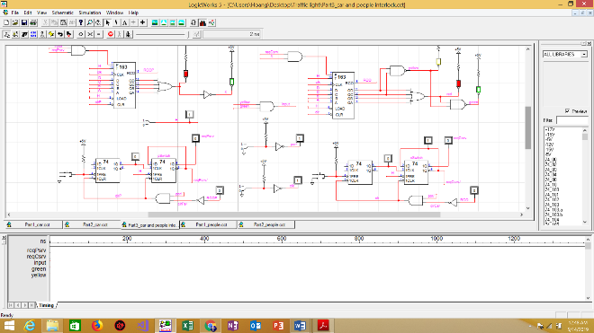

# testing procedures

Phase 1:

**_ Demonstrate the functionality of the Pedestrian State Machine**:

+ Activate the switch (as if a pedestrian approaches the crossing).

+ Apply a clock and see if the RED LED turns off and the GREEN LED turns on

+ Apply a clock and see if the GREEN LED turns off and the RED LED turns on.

**_ Demonstarte the functionality of the Car State Machine:**

+ Activate the switch (as if a car approaches the crossing).

+ Apply a clock and see if the GREEN LED turns on

+ Apply a clock and see if the YELLOW LED stays on

+ Apply a clock and see if the RED LED turns on.

Phase 2:

**_ Demonstrate the functionality of the Pedestrian State Machine:**

+ Activate the switch (as if a pedestrian approaches the crossing).

+ Apply a clocks and see if the GREEN LED turns on and stays on for the specified number of clocks

+ Apply a clock and see if the RED LED turns on.

**_ Demonstrate the functionality of the Car State Machine:**

+ Activate the switch (as if a car approaches the crossing).

+ Apply a clock and see if the GREEN LED turns on and stays on for the specified number of clocks

+ Apply a clock and see if the YELLOW LED stays on for the specified number of clocks

+ Apply a clock and see if the RED LED turns on.

Phase 3:

**_ Demonstrate the functionality of the Pedestrian State Machine:**

+ Activate the ped switch (as if a pedestrian approaches the crossing).

+ Apply a clock and see if the GREEN LED turns on and stays on for a number of clocks (10 more clocks)

+ Activate the car switch

+ Apply the remaining clocks (4 more clocks) and see if ped GREEN light is still on

+ Apply a clock and see if the RED LED turns on.

+ Continue with the car switch demo

**_ Demonstrate the functionality of the Car State Machine**:

+ Activate the car switch (as if a car approaches the crossing), if not already activated from the pedestrian state machine demo

+ Apply a clock and see if the GREEN LED turns on

+ Apply a clock and see if the GREEN LED stays on for several clocks (10 clocks)

+ Activate the pedestrian switch

+ Apply a clock and see if the YELLOW LED turns on and stays on for the specified number of clocks (3 more clocks)

+ Apply a clock and see if the RED LED turns on.

# testing results

In three states, the simulation works properly follow the instruction of lab manual and each state is a step to build a complete traffic light. The whole ideal of this lab is warp in phase 3 where people traffic and car traffic interlock each other. The testing circuit is successful throughout the lab since it is quite easy follow the step by step in the lab manual.

# Conclusion

Throughout the lab, this traffic light lab experience is wrapping all the knowledge and materials that students have learn throughout the course to design a perfect interlock traffic light based on 99% similarity of real traffic light. The lab is successful giving student more experience and giving students ideals to solve problems in real life and prepare for the future.

1. appendices and Referenc